**INTERNSHIP REPORT**

**Edunet Power BI:**

**Sustainable Supply Chain Performance View Internship**

**P(2)**



**Intern Name: Sneha  
Internship Period: 4 Weeks  
Date: 22nd Jan 2025**



**Week 1 Internship Report**

# Introduction

The **Edunet Power BI Sustainable Supply Chain Performance Internship** is designed to provide hands-on experience in **business intelligence and data analytics**. This program allows interns to explore real-world **supply chain datasets**, extract meaningful insights, and apply **data transformation techniques**.

In **Week 1**, the focus was on **loading CSV data into Power BI**, performing essential **data cleaning and transformation**, and preparing datasets for analysis. The dataset consists of **multiple tables**, including **Inventory, Manufacturing, Supplier, and Supply Chain**, each containing **key metrics** for supply chain performance.

The purpose of this report is to outline the **tasks performed**, the **methodologies used**, and the **key insights** derived from the dataset. These tasks lay the foundation for building **data-driven dashboards and reports** in Power BI.

This internship focuses on analysing sustainable supply chain performance using Power BI. In Week 1, we worked on loading CSV files, transforming data, and analysing key supply chain metrics. This report provides details of the tasks completed, along with dataset structure and transformation steps.

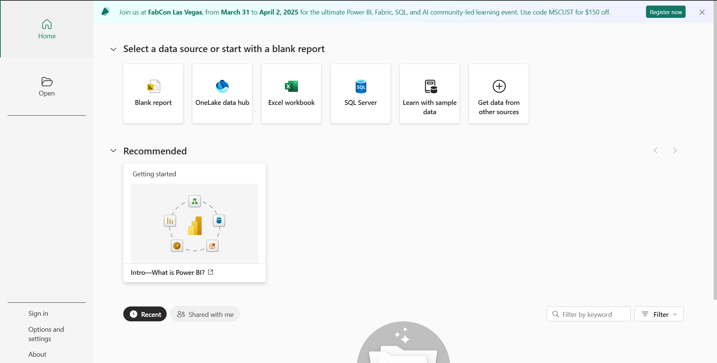

# 2. Week 1 Tasks

## Loading and Extracting CSV File in Power BI

1.Open Power BI and navigate to 'Get Data'.

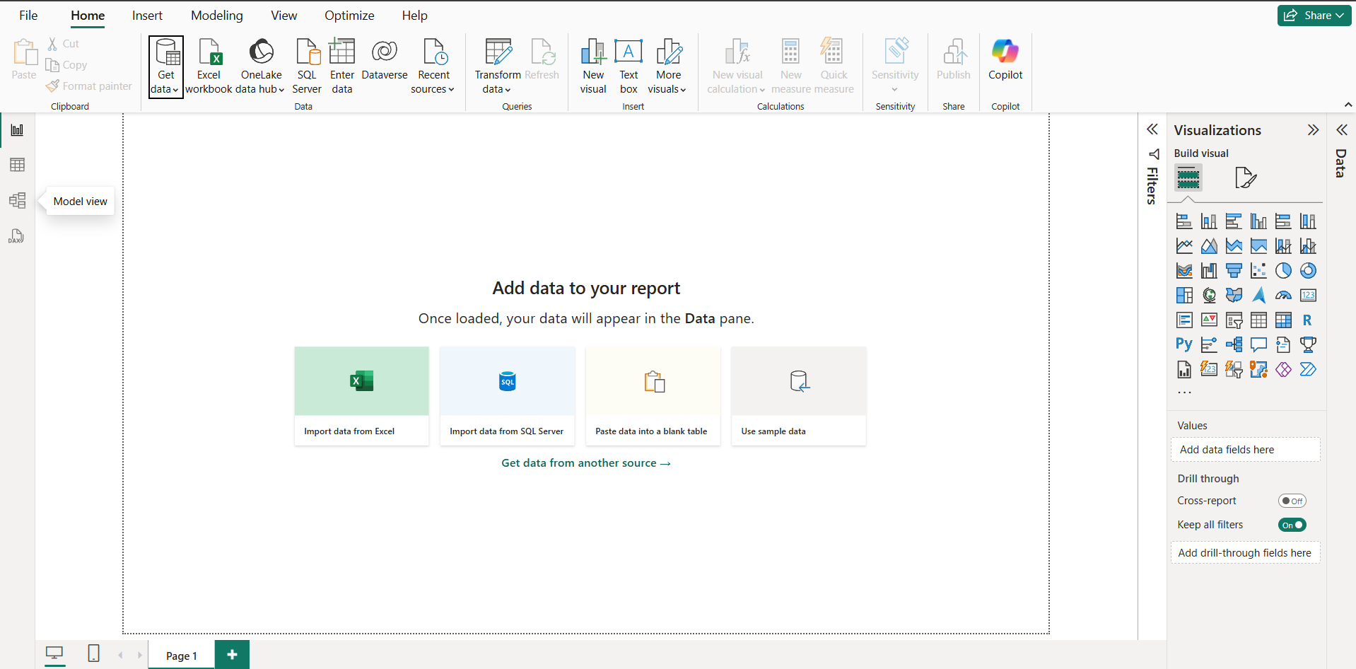

1. Select 'CSV' and choose the dataset.

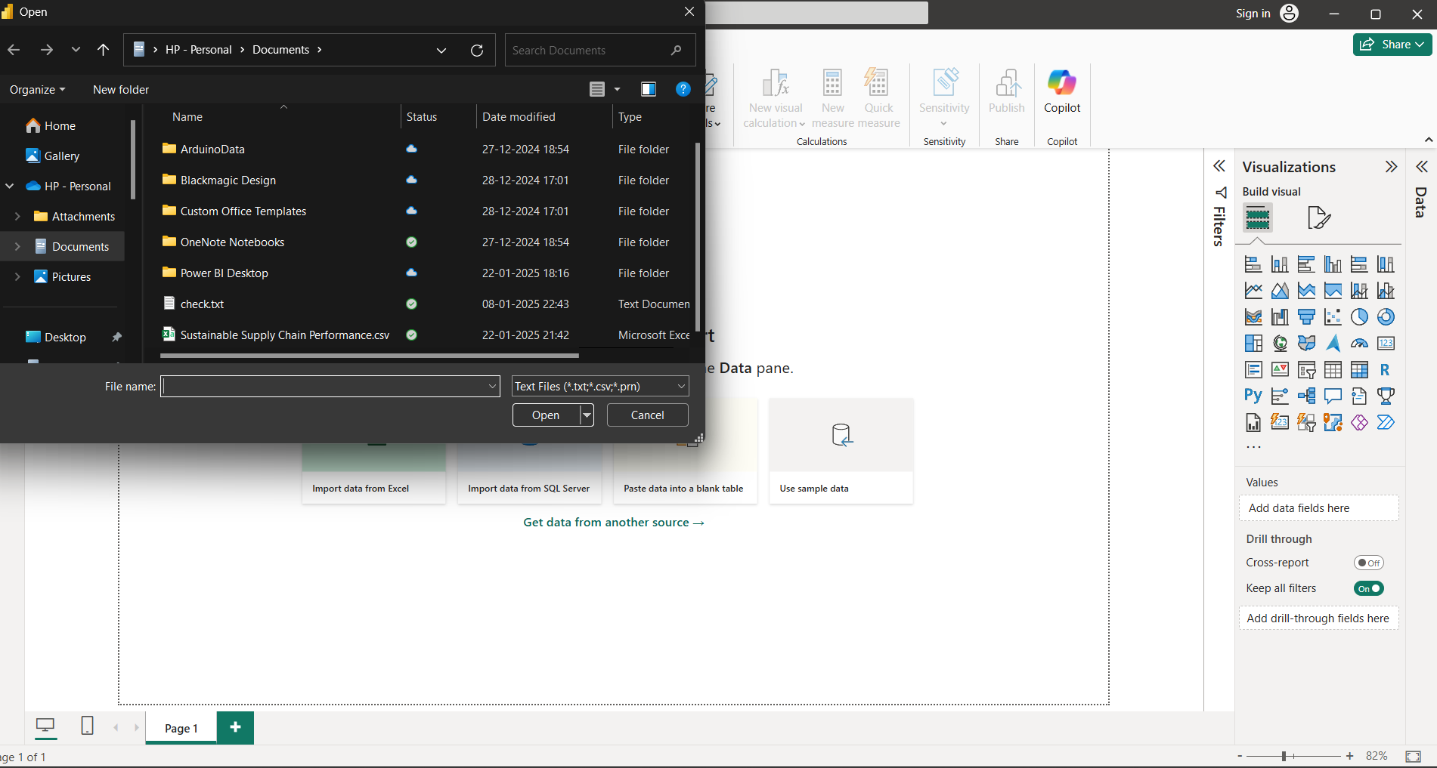

1. Load the data and inspect the columns.

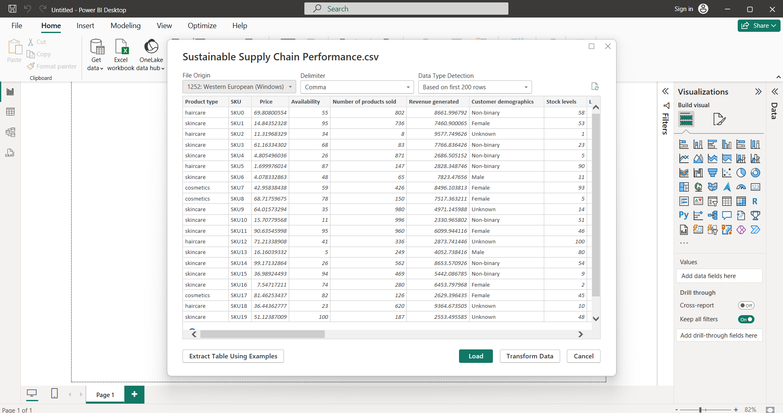

1. Identify key fields such as product type, SKU, availability, and lead times.

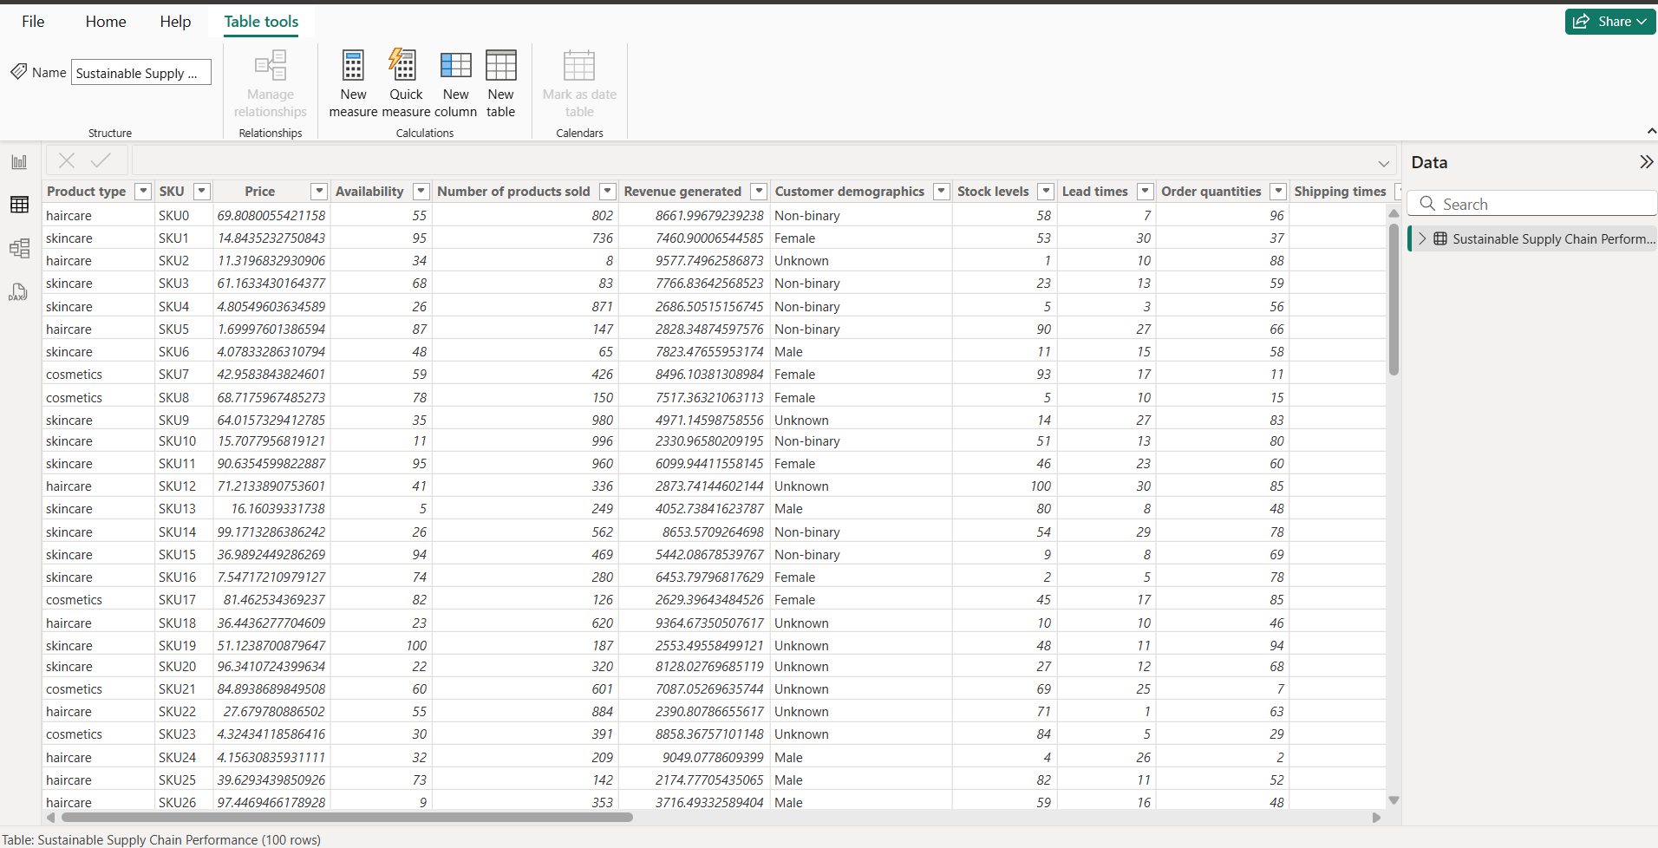

## Transformation of Data

Data transformation was performed on various tables to clean, organize, and prepare data for analysis. Key tables included Inventory, Manufacturing, Supplier, and Supply Chain.

### A) Inventory Table

Key attributes: Product Type, SKU, Availability, Number of Products Sold, Customer Demographics, Stock Levels, Lead Times, Order Quantities, Revenue Generated.

* **Product Type** – Categorizes the products.
* **SKU (Stock Keeping Unit)** – Unique identifier for each product.
* **Availability** – Indicates whether the product is in stock.
* **Number of Products Sold** – Total sales for each product.
* **Customer Demographics** – Data about customer age, location, and preferences.
* **Stock Levels** – Current inventory count.
* **Lead Times** – Time taken for restocking.
* **Order Quantities** – Quantity ordered per transaction.
* **Revenue Generated** – Total revenue from solding product.

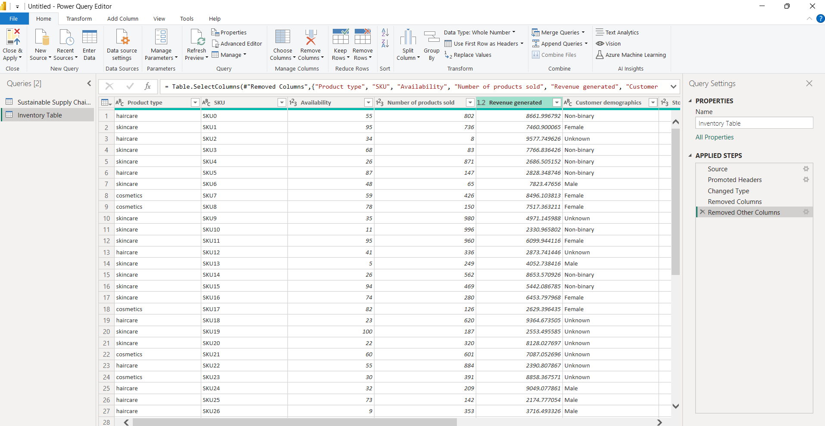

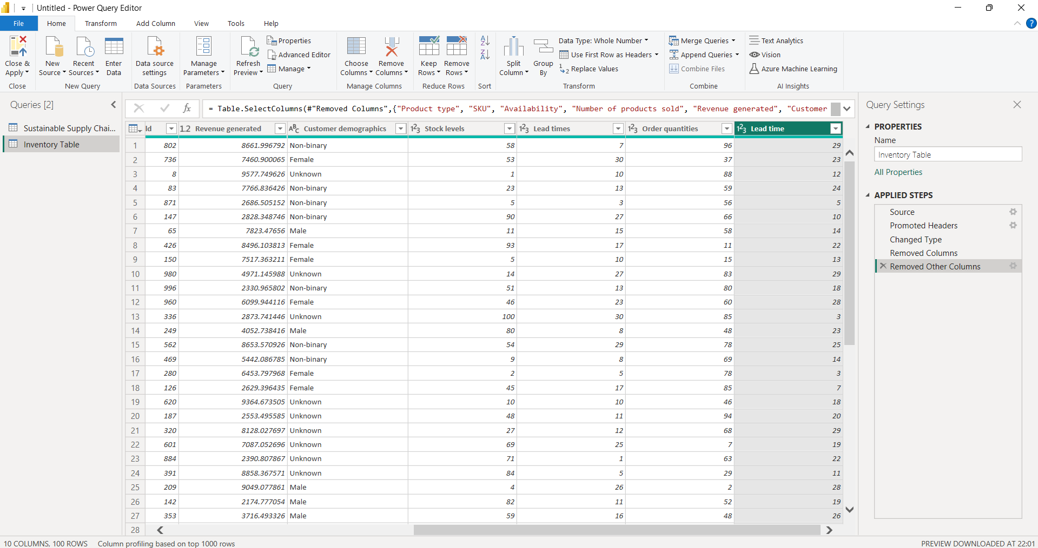

### B) Manufacturing Table

Key attributes: Product Type, SKU, Production Volumes, Manufacturing Lead Time, Manufacturing Costs, Inspection Results, Defect Rates.

* + **Product Type** – Specifies the category of the product.
  + **SKU** – Unique identifier for tracking production.
  + **Production Volumes** – Number of units produced.
  + **Manufacturing Lead Time** – Time taken to produce a product.
  + **Manufacturing Costs** – Expenses incurred in production.
  + **Inspection Results** – Quality check reports.
  + **Defect Rates** – Percentage of defective produc

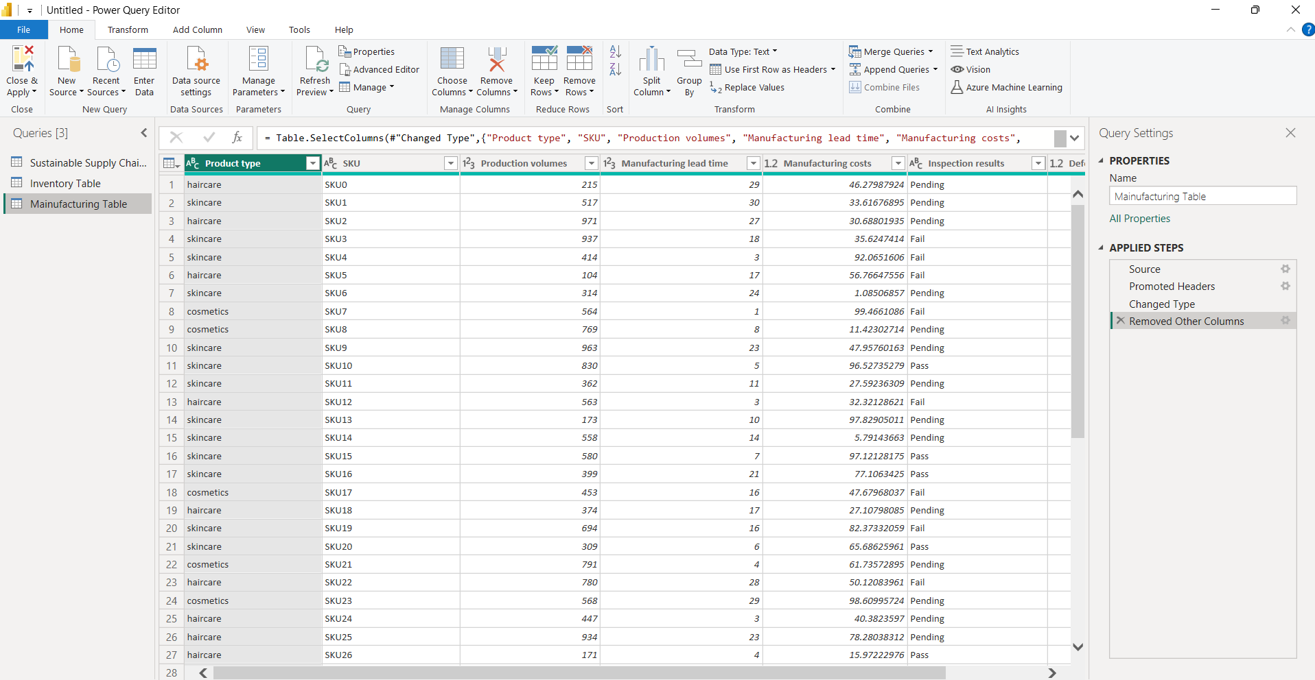

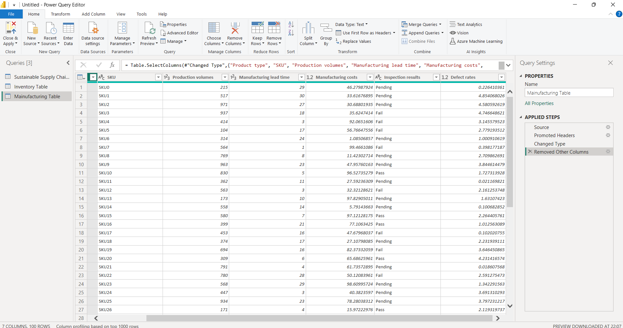

### C) Supplier Table

Key attributes: Supplier Name, Location, Lead Time, Transportation Modes, Routes.

### Supplier Name – Name of the supplier.

### Location – Geographic location of the supplier.

### Lead Time – Time taken for the supplier to deliver goods.

### Transportation Modes – Methods used for shipping (air, road, sea, rail).

### Routes – Supply chain paths used for transportation.

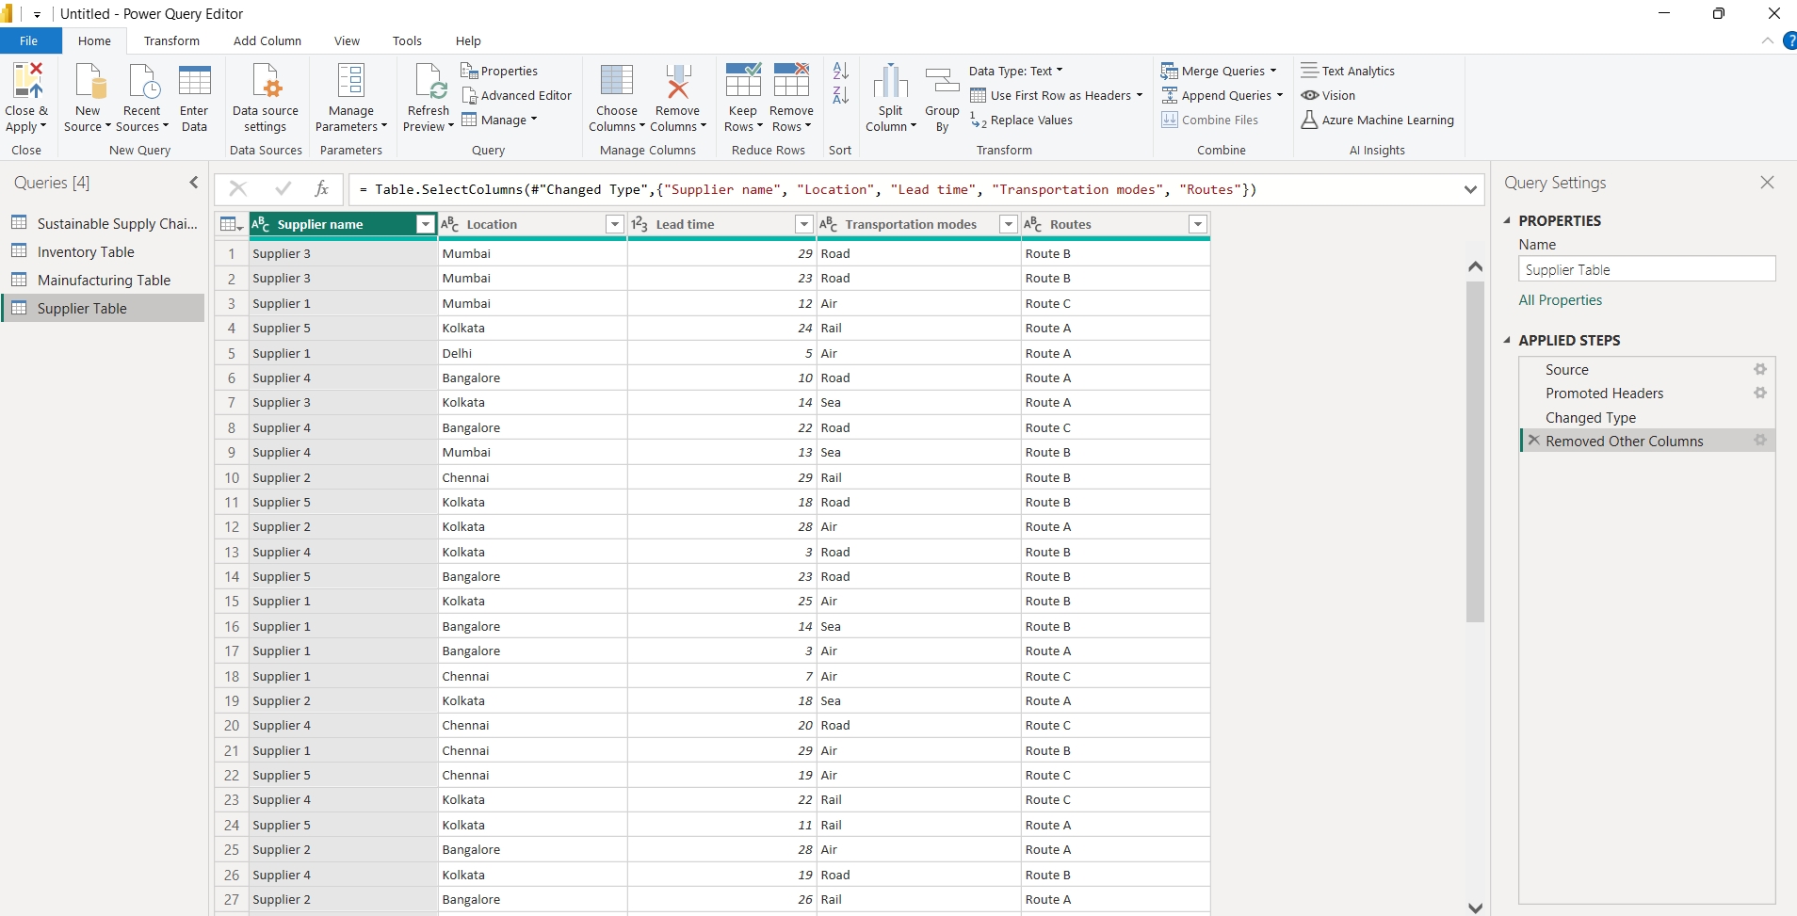

### D) Supply Chain Table

Key attributes: Product Type, SKU, Price, Availability, Number of Products Sold, Revenue Generated, Customer Demographics, Stock Levels, Lead Times, Order Quantities, Shipping Times, Shipping Carriers, Shipping Costs, Supplier Name, Location, Lead Time, Transportation Modes, Routes.

* + **Product Type** – Categorization of products.
  + **SKU** – Unique identifier for inventory tracking.
  + **Price** – Cost per unit of the product.
  + **Availability** – Stock status of the product.
  + **Number of Products Sold** – Total sales volume.
  + **Revenue Generated** – Total income from sales.
  + **Customer Demographics** – Information about customer purchasing trends.
  + **Stock Levels** – Available product inventory.
  + **Lead Times** – Supply chain delays and processing times.
  + **Order Quantities** – Units ordered per transaction.
  + **Shipping Times** – Duration taken to ship orders.
  + **Shipping Carriers** – Logistics providers handling deliveries.
  + **Shipping Costs** – Expenses incurred in transportation.
  + **Supplier Name** – Name of the product supplier.
  + **Location** – Supplier’s geographical location.
  + **Lead Time** – Time required for delivery.
  + **Transportation Modes** – Methods used for shipment.
  + **Routes** – Paths followed in the supply chain network.

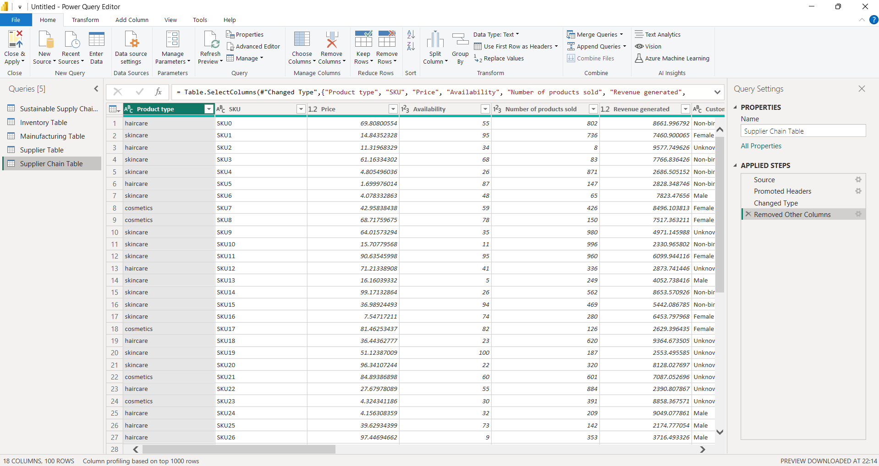

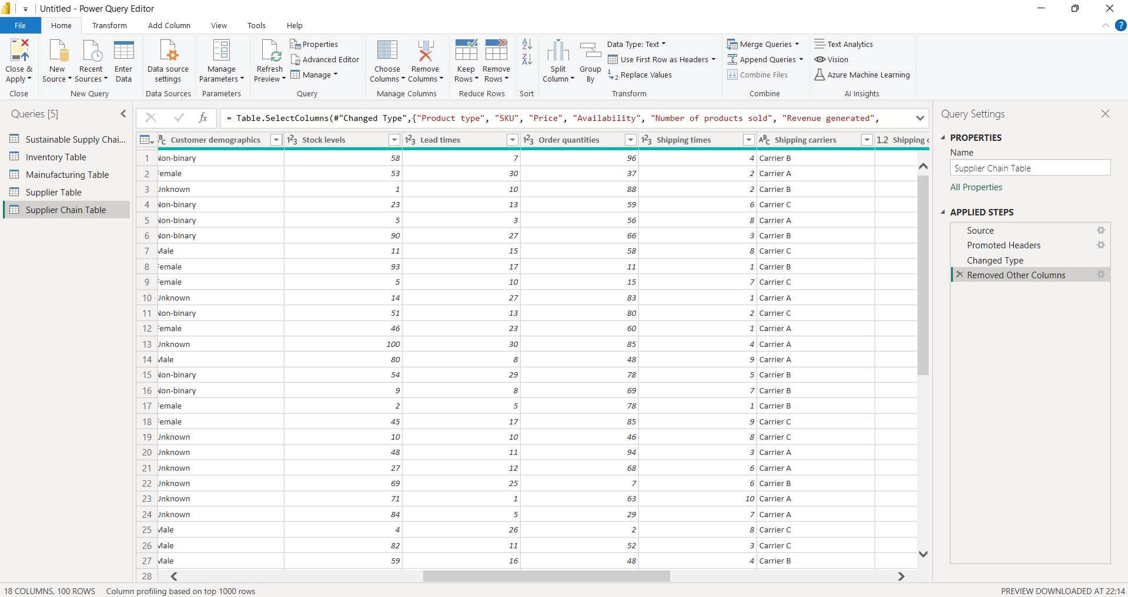

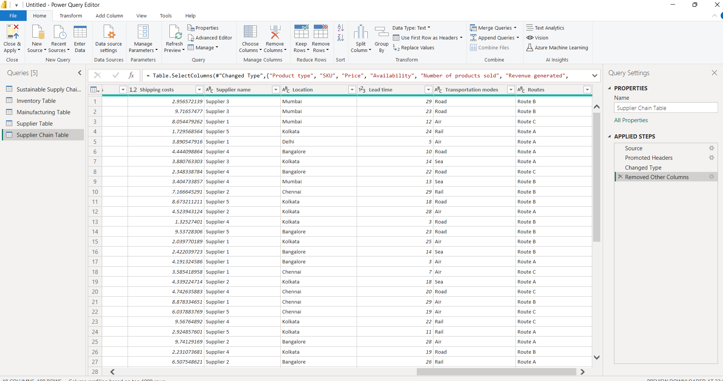

**Conclusion**

During **Week 1**, essential tasks related to **data loading, extraction, and transformation** were performed using Power BI. The dataset was structured into different **tables**, each containing **crucial supply chain metrics**. This process provided a strong foundation for **further data analysis and visualization**, which will be covered in the upcoming weeks.

**Dataset Used :**

**CSV File link:** **Sustainable Supply Chain Performance.csv** ()

**Power BI file link:** [**Power BI file(** )](https://d.docs.live.net/36eb3ee4a40dbfc8/Documents/supply%20chain%20performace_week01.pbix)